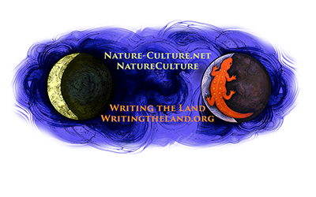
Dear Poets,

For Spring 2024, we are only open to poets applying for the Rensselaer Plateau project in western New York. We look forward to being open to poets in other parts of the country when we have lands for you to apply for, and anticipated this will be late 2024 or early 2025, as all our books are full through 2025.

To apply for NY Rensselaer Plateau, please send your bio, photo, and 3 example poems Labelled YourLastName-bio, YourLastName-photo, YourLastName-poems (all poems in 1 document) to: annondras@gmail.com

With thanks for your interest,
Lis

